Real-Time Tracking and Visualization of the International Space Station Using WTIA API
(Group Project)
Andrew Tan Joe Wen, ‘Affan Najiy bin Rusdi, Muhammad Ikhwan bin Mohd Azahari, Muhammad Thaqif Adli bin Abdul Aziz
Student ID: 22010175, 22010453, 22010398, 24006524
Bachelor of Computer Science, Universiti Teknologi PETRONAS
andrew_22010175@utp.edu.my, affan_22010453@utp.edu.my, ikhwan_22010398@utp.edu.my, muhammad_24006524@utp.edu.my

1.0 INTRODUCTION & BACKGROUND

The International Space Station (ISS) is a unique space laboratory that continuously orbits Earth, and its real-time data provides valuable insights into orbital mechanics, telemetry, and space monitoring. With the rapid development of the Internet of Things (IoT), it is now possible to collect, analyse, and visualize such data efficiently using cloud-based and web technologies. This project aims to utilize IoT concepts to design a system capable of fetching and storing ISS telemetry data such as latitude, longitude, altitude, and velocity from the “Where The ISS At” (WTIA) API. By doing so, the project allows for continuous tracking of the ISS’s position and movement over time.
Additionally, this project explores data analytics techniques to calculate parameters like the maximum and minimum longitude values and altitude changes throughout the observation period. The system will also present this information visually through a live 3D dashboard that displays the ISS orbiting Earth, providing a clear and interactive way to understand real-time satellite motion.

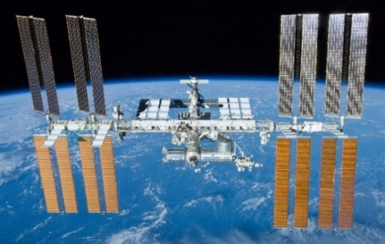
Figure 1: An Image of the ISS as seen from space

1.1 OBJECTIVE

The main objective of this project is to design and implement a low-cost IoT system that continuously monitors and records the International Space Station’s telemetry data for at least three days. The system will periodically fetch data from the WTIA API, store the historical location records, and analyse them to determine trends such as altitude variations and longitude extremes.
Another key objective is to visualize the ISS’s movement on a 3D Earth model, where the satellite’s position updates dynamically according to real-time latitude and longitude data. Additionally, the system aims to display relevant satellite information, including altitude and location details, on an interactive dashboard. Through this project, the goal is to demonstrate the integration of IoT data acquisition, storage, analytics, and visualization into one cohesive and functional monitoring system.

2.0 PROBLEM STATEMENT

The problem is the necessity of continuous monitoring of the ISS, which is crucial for space research, orbital predictions, and anomaly detection. The task is to collect data of the ISS’s longitude, latitude, and altitude changes. There are some issues to be faced to record the real-time telemetry data challenges, like the API, which state rate limits in the WTIA API documentation, which has a 1-second rate limit. In addition, there may be data gaps from the continuous fetching, as there may be latency.
There is also the requirement of the project task to collect the data over the course of three days, which may yield around 259,200 rows of observation, which in turn may cause inadequate storage of the data in the designated database for the program.
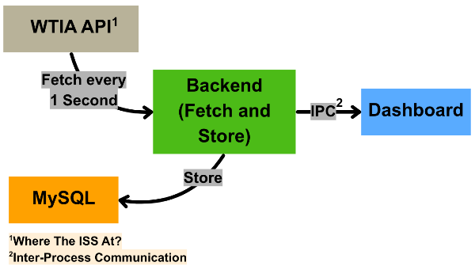
Figure 2: Architecture overview

3.0 SYSTEM DESIGN

The architecture of the project executed is as shown in Figure 2. The components and tools that are used are stated in Table 1 below.

Section | Software
API | WTIA
Server | Node.js
Frontend | React  JavaScript  r3f-globe  r3f-drei  Leaflet  Tailwind CSS
Database | MySQL
Table 1: Components and tools used in project

The server section has Node.js scripts that will fetch the telemetry data of the ISS from the WTIA API. It will fetch the data every 1 second. In addition, the data fetched will simultaneously be stored in a local MySQL database containing a table for the telemetry data. Then, there is a script that will provide a REST API via a URL provided by a script for the frontend section to link to for the visualization.
The frontend will then acquire the data fetched from the REST API to visualize the position of the ISS in a dashboard. There are basically two separate subsections of the dashboard whereby the first one will show the current position of the ISS by providing the latitude and longitude of the ISS. There is also a line chart that is continuously updated from the latest data URL provided to show the changes of altitude. Furthermore, there is an update for a 3D Earth globe with a marker to show the current position of the ISS, while the map shows the visualization of the ISS on a flat map.

4.0 DATABASE DESIGN

The database for this project is designed to store ISS telemetry data in a structured and reliable way so that the system can capture and analyze at least three days of continuous satellite movement. MySQL is used as the main storage platform because it is stable, lightweight, and integrates well with the Node.js backend. Each time the system fetches new telemetry from the WTIA API, a new entry is inserted into a table containing latitude, longitude, altitude, velocity, and the timestamp provided by the API. An additional field called fetched_at is also stored to record the exact local time when the server retrieved the data. This helps differentiate between the satellite’s own timestamp and the system’s data-collection time, which is important when reviewing gaps or delays in the telemetry. Over several days, the table grows into a comprehensive log of the ISS’s path, making it possible to compute analytics such as max/min longitude and changes in altitude.
To make the stored data more accessible and useful outside the application, the system also includes options to export the historical telemetry into CSV and PDF formats. The CSV export is suitable for analysis in tools which in this case R Studio is used, while the PDF export is helpful for reporting or attaching diagrams to documentation. The retrieved data are presented in Table 3 in the PDF format. Altitude information stored in the database is especially meaningful because it allows users to observe how the ISS’s orbital height fluctuates, which is consistent with known trends described by [3] regarding the station’s typical altitude range and velocity behaviour. Overall, the database design focuses on efficient long-term data logging while still supporting analytics, visualization, and external data usage.
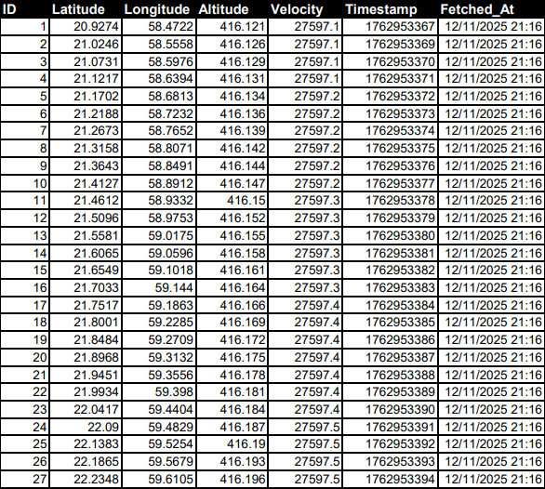
Table 3: Sample of data fetched

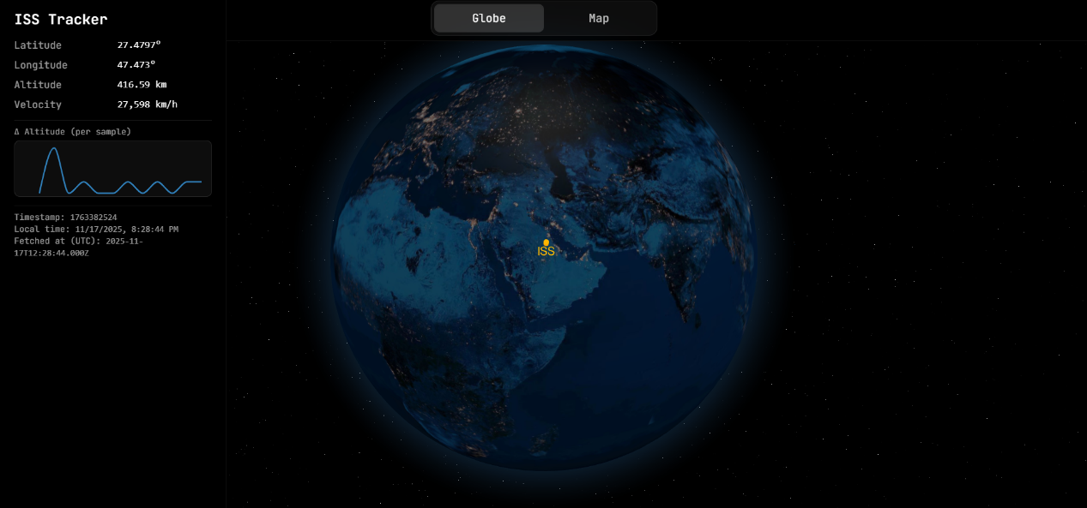
Figure 3: Dashboard of globe page

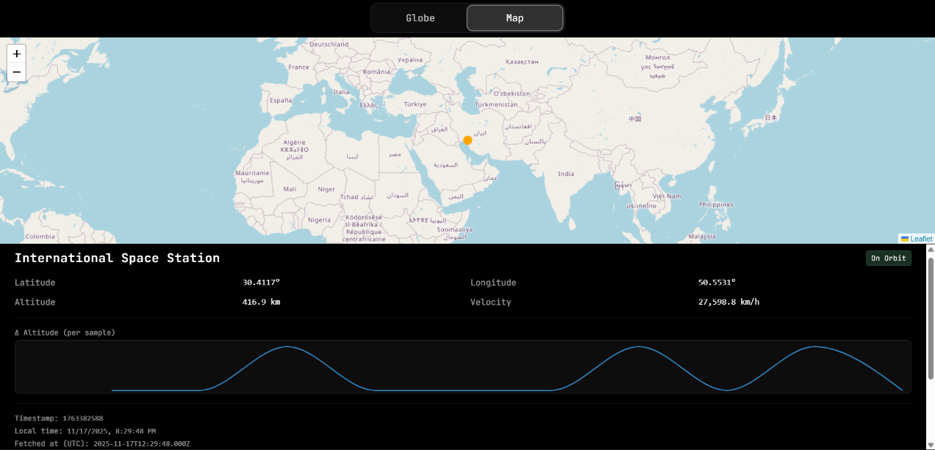
Figure 4: Dashboard of map page
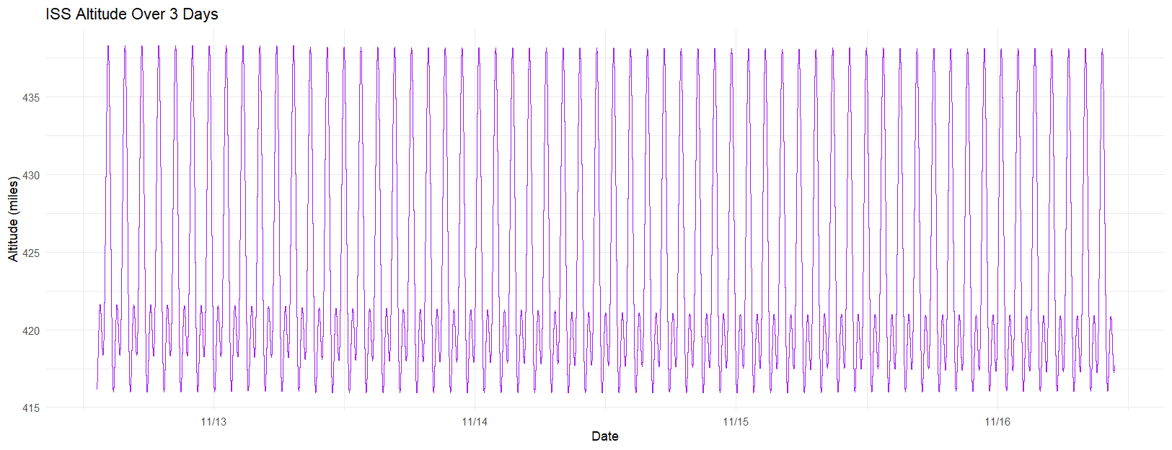
Figure 5: Line chart visualizing the changes in altitude of the ISS

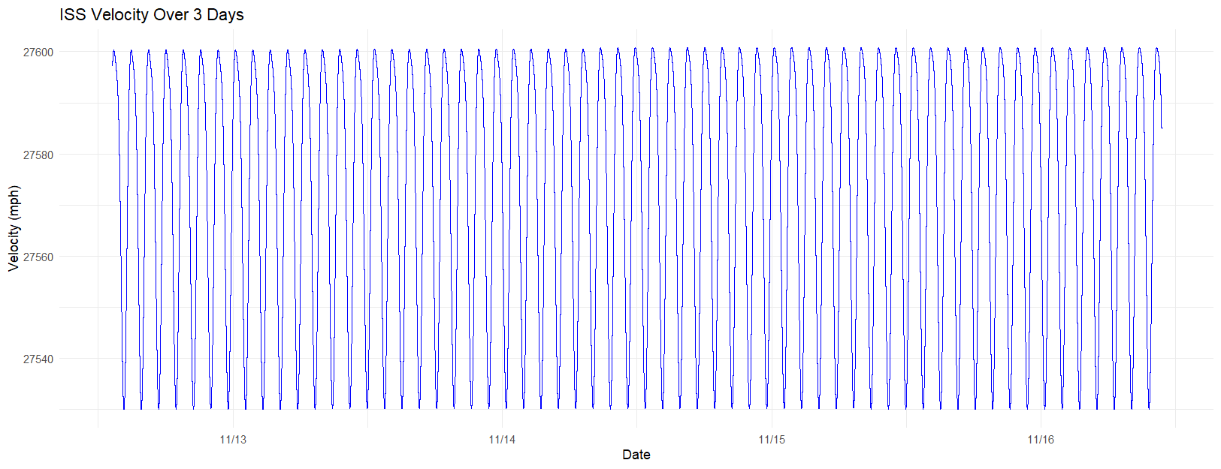
Figure 6: Line chart visualizing the velocity of the ISS

5.0 Data Visualization

The tools that were used for the visualization on the dashboard are the r3f-globe and r3f-drei for the 3D Earth globe. Leaflet was used for the web map. Meanwhile, Tailwind CSS was used to create a responsive layout depending on the user’s screen display. Recharts was used to design the altitude changes chart. In addition, RStudio was used to do a separate analysis and visualization based on the data collected in the MySQL.
The dashboard design for the globe page consists of the left panel, which shows the live telemetry card, which consists of the latitude, longitude, altitude, velocity, and the altitude changes after each fetched sample. On the right-hand side of the dashboard is the 3D Earth model with a marker of the current location of the ISS labelled “ISS”.
For the design of the map page, a flat map is projected on the top of the page while the telemetry data is shown at the bottom of the page. The information displayed at the bottom panel is the same as the globe page. However, the map only shows the current dot and is updated using the REST API from the server section.
A few insights have been gained after the data collection over the course of 3 days from 12 November 2025. Using RStudio, a line chart was produced to show the changes of altitude, while another one was to visualize the velocity of the ISS, as shown in Figure 5 and Figure 6. The maximum altitude reached was 415.9 miles (669.33 km), while the minimum altitude was 438.3 miles (705.38 km). The ISS mostly stayed at an average altitude of 424.1 miles (682.52 km). Meanwhile, the velocity of the ISS reached a maximum velocity of 27,601 mph (44,419.5 km/h), and the minimum velocity was 27,530 mph (44,305.24 km/h). Consequently, the average velocity of the ISS was 27,573 mph (44,374.44 km/h).

6.0 COST CONSIDERATIONS

The budget breakdown of the project is as shown below in Table 3. The budget is divided into the sections of the components and tools used in the project based on the list in Table 1.

Item | Cost (RM)
API | 0.00
Server | 0.00
Frontend | 0.00
Database | 0.00
Total | 0.00
Table 3: Budget breakdown of project

In short, the API, server, frontend, and database tools did not have any expenses to be used, as all the programs were free and available online. However, it would be better to use a cloud platform for the application hosting, database, and analytics. For instance, the application could be hosted using Render or Amazon Web Services for ease of use rather than deploying the program locally.

7.0 CONCLUSION

In conclusion, this project successfully demonstrated how an IoT-based system can be used to collect, store, analyse, and visualise real-time telemetry data from the International Space Station. By using the WTIA API to fetch key parameters such as latitude, longitude, altitude, velocity, and timestamp, the system was able to record continuous ISS movement over the required three-day period. The integration of Node.js, MySQL, and REST APIs ensured that the data flow from the API to the database and then to the dashboard remained stable throughout the observation window. The system also produced meaningful analytics, such as identifying maximum and minimum longitude values and monitoring altitude changes, which helped give a clearer picture of the ISS’s orbital behaviour. The 3D Earth model, flat map, and live telemetry card further enhanced the project by providing an interactive and visually engaging way to understand satellite motion.
However, while the system achieved its main objectives, several limitations were noted. The WTIA API’s one-request-per-second rate limit sometimes restricted how much data could be collected, especially during moments of network delay or temporary connection loss. Storing large amounts of telemetry data over multiple days also raised concerns about long-term storage capacity and the need for more scalable database solutions if the system were to run for weeks instead of days. Additionally, the accuracy of the altitude analysis depended heavily on the consistency of the fetched data, which could sometimes fluctuate due to API-side rounding or transmission latency. Despite these limitations, the project provided strong insight into IoT data acquisition, real-time visualisation, and backend and frontend integration, and it serves as a solid foundation for future enhancements such as cloud deployment or predictive modelling of the ISS orbit.

REFERENCES

[1] | L. E. Warren, “International Space Station open-source data,” Patterns, vol. 1, no. 9, pp. 1-2, 2020.
[2] | C. A. Evans, J. A. Robinson and J. M. Tate-Brown, “Research on the International Space Station: An overview,” in AIAA Space 2009 Conf. Exhib, California, 2009.
[3] | J. Newland, “A simple model to determine the altitude and velocity of the I.S.S.: How can simple measurements of the orbital period of a satellite be used to calculate its altitude and velocity?,” Dept. Physics, University of Houston, Houston, TX, USA, Texas, 2016.
[4] | B. Shump, “Where the ISS At? API Documentation,” [Online]. Available: https://wheretheiss.at. [Accessed 12 November 2025].

LINKS
1. | Server: https://github.com/AndrewTJW/iot_backend
2. | Dashboard: https://github.com/AndrewTJW/iot_dashboard
3. | Analysis: https://github.com/affannajiy/iot_analysis
4. | Data: https://drive.google.com/drive/folders/1UeIYTjlSvvwc_bOj8c82NkxVUq8smg0p?usp=sharing
5. | Video: https://www.youtube.com/watch?v=tsH1vv8k8K8

